# Python Refresher - 1

1. [Static vs Dynamic Typed Languages](https://medium.com/android-news/magic-lies-here-statically-typed-vs-dynamically-typed-languages-d151c7f95e2b)

2. [Variables vs Objects](https://www.practicaldatascience.org/html/vars_v_objects.html)

3. [Register vs Memory](https://circuitglobe.com/difference-between-registers-and-memory.html)

4. [Mutability vs Immutability](https://medium.datadriveninvestor.com/mutable-and-immutable-python-2093deeac8d9)

5. [First Class Citizens](https://oznetnerd.com/2017/07/14/python-everything-object-first-class-citizens/)

6. [Python, Memory and Objects](https://towardsdatascience.com/python-memory-and-objects-e7bec4a2845)

7. [Compiler vs Interpreter](https://www.javatpoint.com/compiler-vs-interpreter)

8. [Basic Python Constructs](https://www.scaler.com/topics/python/python-first-program/)

9. [Python Control Flow](https://www.scaler.com/topics/python/control-flow-statements-in-python/)

10. [Python Functions](https://www.scaler.com/topics/python/functions-in-python/)

# Python Refresher - 2

1. [List Slicing Personal Notes](https://drive.google.com/file/d/1ewJy9r4KeBdJSjN5dlIGZ6HYBA_A7Bqw/view?usp=sharing)
2. [Internals of List and Tuples (HW)](https://www.youtube.com/watch?v=rTgjOV0uTV0)
3. [Python Data Structures](https://pythongeeks.org/python-data-structures/)
4. [Python Data Structures - 2](https://www.scaler.com/topics/python/list-in-python/)
5. [Mutability and Immutability](https://pythonsimplified.com/mutability-immutability-in-python/)
6. [Concatenate Lists in Python](https://chercher.tech/python-questions/concatenate-list-python)
7. [Nested Lists in Python](https://problemsolvingcode.com/create-nested-list-in-python)

# Python Refresher - 3

1. [Iteration Protocol](https://www.youtube.com/watch?v=JYuE8ZiDPl4)
2. [Python3 Docs](https://docs.python.org/3/tutorial/index.html)
3. [Tuples](https://docs.python.org/3/tutorial/datastructures.html#tuples-and-sequences)
4. [Truth Value Testing](https://docs.python.org/3/library/stdtypes.html#truth)
5. [List Common Operations](https://docs.python.org/3.7/library/stdtypes.html?highlight=list%20copy#common-sequence-operations)
6. [A tic tac toe that wins in the first attempt](https://github.com/satwikkansal/wtfpython#-a-tic-tac-toe-where-x-wins-in-the-first-attempt)
7. [The dir() function](https://docs.python.org/3/tutorial/modules.html#the-dir-function)
8. [Tuple packing and unpacking](https://runestone.academy/ns/books/published/fopp/Tuples/toctree.html)
9. [Why is tuple faster than list in Python? - Stack Overflow](https://stackoverflow.com/questions/3340539/why-is-tuple-faster-than-list-in-python)

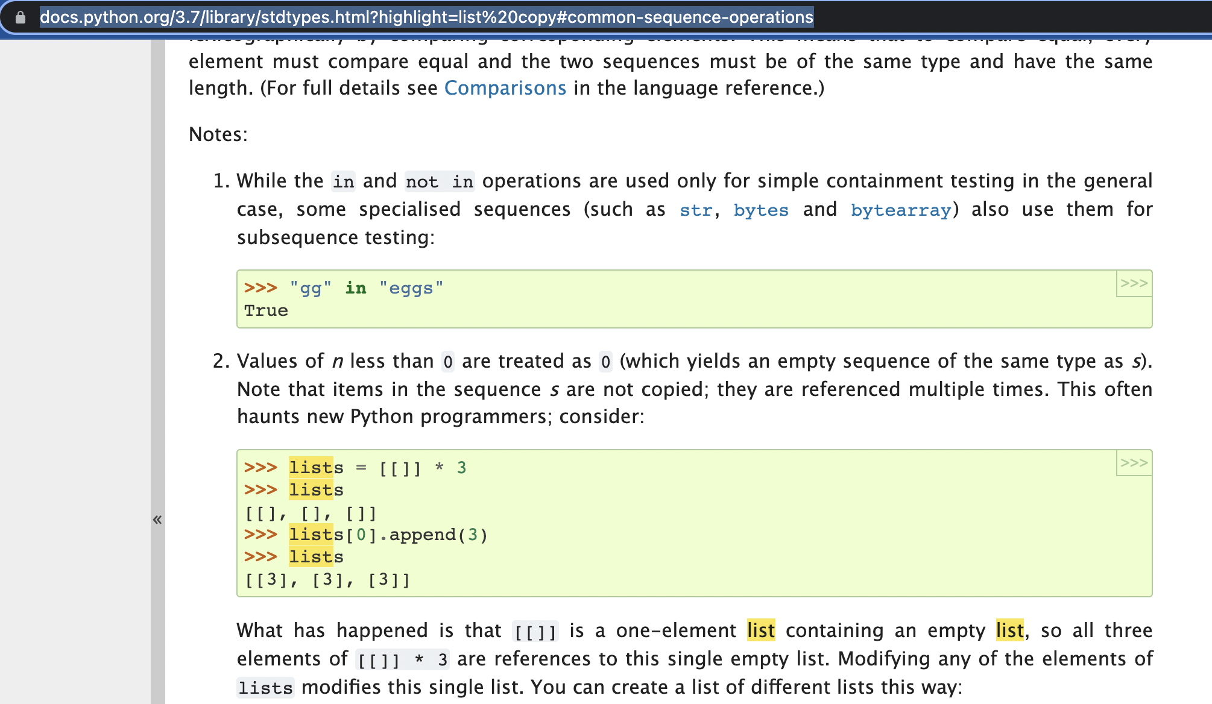

# Python Refresher - 4

1. How to Approach a Problem
2. Comprehensions - List, Set, Dictionary
3. Nested Comprehension
4. Dictionaries
5. Sets
6. Set Operations
7. Nearest 5 Points
8. Revision Strategy
   1. Bookmarking
   2. [Spaced Repetition](https://e-student.org/spaced-repetition/#:~:text=Spaced%20repetition%20is%20a%20memory%20technique%20that%20involves,mind%20and%20forces%20you%20to%20use%20active%20recall.)